**Backward Selection Method Options Testing**

**proc** **glmselect** data=housing plots=all;

class MSZoning Street Alley LotShape LandContour Utilities LotConfig LandSlope Neighborhood Condition1 Condition2 BldgType HouseStyle RoofStyle RoofMatl Exterior1st Exterior2nd MasVnrType ExterQual ExterCond Foundation BsmtQual BsmtCond BsmtExposure BsmtFinType1 BsmtFinType2 Heating HeatingQC CentralAir Electrical KitchenQual Functional FireplaceQu GarageType GarageFinish GarageQual GarageCond PavedDrive PoolQC Fence MiscFeature SaleType SaleCondition MSZoning;

model SalePrice = GrLivArea MSSubClass MSZoning LotFrontage LotArea Street Alley LotShape LandContour Utilities LotConfig LandSlope Neighborhood Condition1 Condition2 BldgType HouseStyle OverallQual OverallCond YearBuilt YearRemodAdd RoofStyle RoofMatl Exterior1st Exterior2nd MasVnrType MasVnrArea ExterQual ExterCond Foundation BsmtQual BsmtCond BsmtExposure BsmtFinType1 BsmtFinSF1 BsmtFinType2 BsmtFinSF2 BsmtUnfSF TotalBsmtSF Heating HeatingQC CentralAir Electrical _1stFlrSF _2ndFlrSF LowQualFinSF BsmtFullBath BsmtHalfBath FullBath HalfBath BedroomAbvGr KitchenAbvGr KitchenQual TotRmsAbvGrd Functional Fireplaces FireplaceQu GarageType GarageYrBlt GarageFinish GarageCars GarageArea GarageQual GarageCond PavedDrive WoodDeckSF OpenPorchSF EnclosedPorch _3SsnPorch ScreenPorch PoolArea PoolQC Fence MiscFeature MiscVal MoSold YrSold SaleType SaleCondition / selection = backward choose=adjrsq select=adjrsq stop=adjrsq showpvalues stats=all;

**run**;

**Option Tests:**

selection = backward choose=adjrsq select=adjrsq stop=adjrsq

(Adjusted R-square statistic)

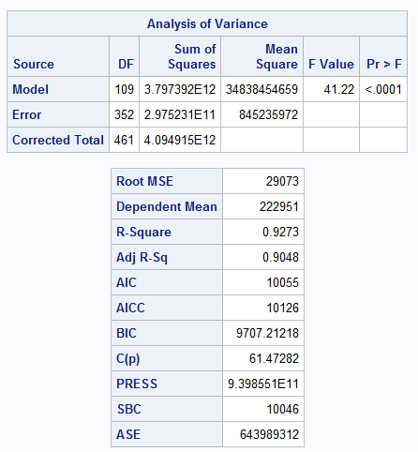

selection = backward

(No options)

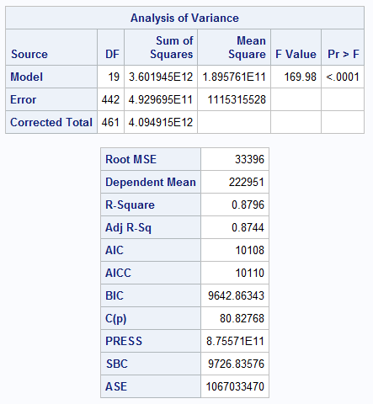

selection = backward choose=cp select=cp stop=cp

(Mallows C(p) statistic)

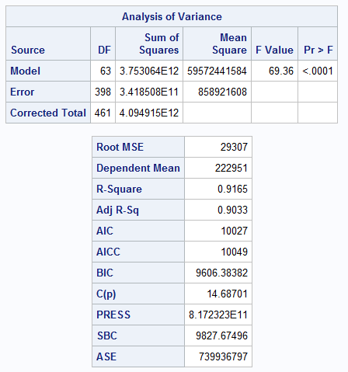

selection = backward choose=press select=press stop=press

(Predicted residual sum of squares)

**\*\*\*This method will stop immediately using backward selection – all variables get included.**

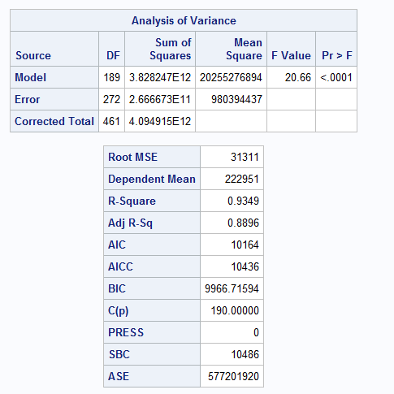

selection = backward choose=cv select=cv stop=cv

(Predicted residual sum of square with https://support.sas.com/documentation/cdl/en/statug/63033/HTML/default/images/statug_glmselect0001.png-fold cross validation)

**\*\*\*This method will stop immediately using backward selection – all variables get included.**

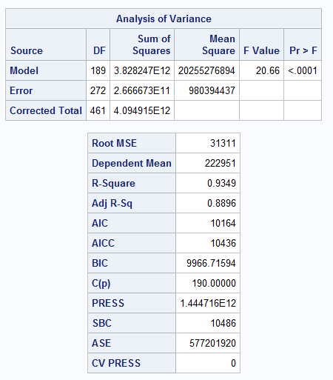

selection = backward choose=aic select=aic stop=aic

(Akaike information criterion)

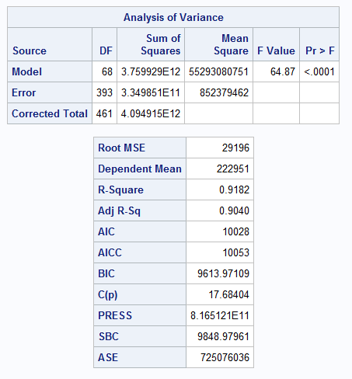

selection = backward choose=bic select=bic stop=bic

(Sawa Bayesian information criterion)

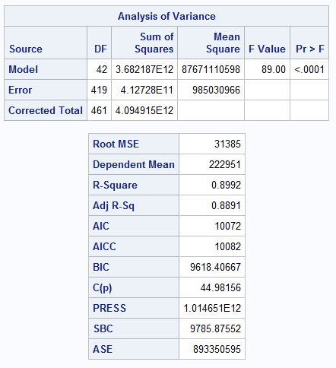

selection = backward choose=sbc select=sbc stop=sbc

(Schwarz Bayesian information criterion)

